

1. Go to [www.bitstrips.com](http://www.bitstrips.com) and click on ‘Create’ on the left side of the page.

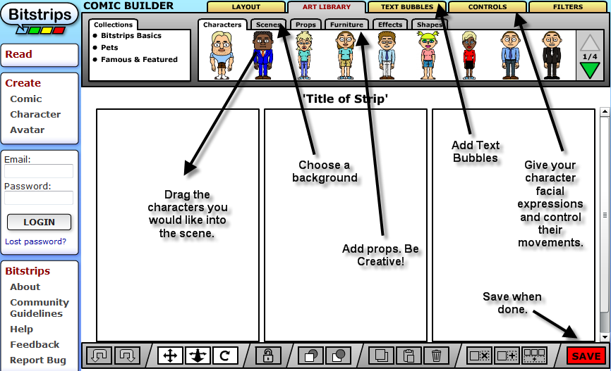

Bitstrips is an easy to use comic building site.  Students (and teachers) of all ages can use this webtool to create a comic cell, strip, or story and then share it with their peers or the world.  The possibilities are endless with this simple to use website.  You simply click on attributes of a character's build, pick the colors, the background, and add dialogue.  It would be a fantastic tool to use with illustrating a scene from a novel, or even to help a student understand a complex theory such as gravity in science.  Bitstrips is fun, free, and very useful as a teaching tool.