It’s easy to build ZooBurst books! Basic account holders can have up to 10 active books at a time. Use Username: now@4aplus.com and Password: zooburst. Then click on the 'Books' link and click on the 'New Book' button to create a new book.

ZooBurst will ask you for some basic information about your book, such as its title, a brief description and a privacy level (books can be set to completely public, completely private or password protected). Once you click the Save button you will be redirected to the ZooBurst Book Builder that lets you visually construct you own pop-up books.
The left side of the screen contains the 'Pictures' panel. This panel lets you search for pictures via the Open Clip Art Library as well as upload your own photos to ZooBurst. To search, type in a keyword into the blank provided - if ZooBurst finds a match you will see a series of thumbnails that correspond to with your request. Clicking on a thumbnail will cause that character to appear in your book.
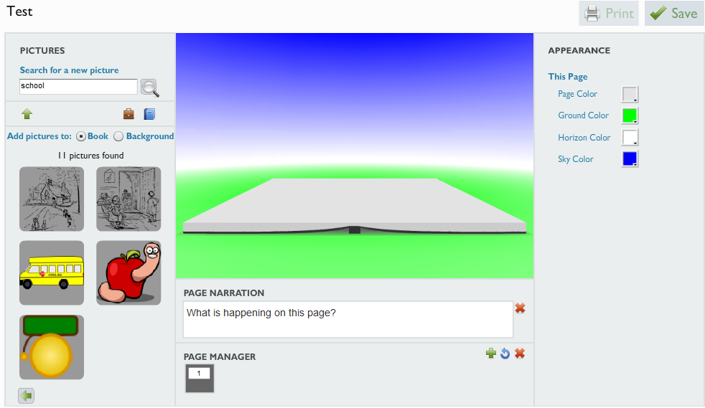
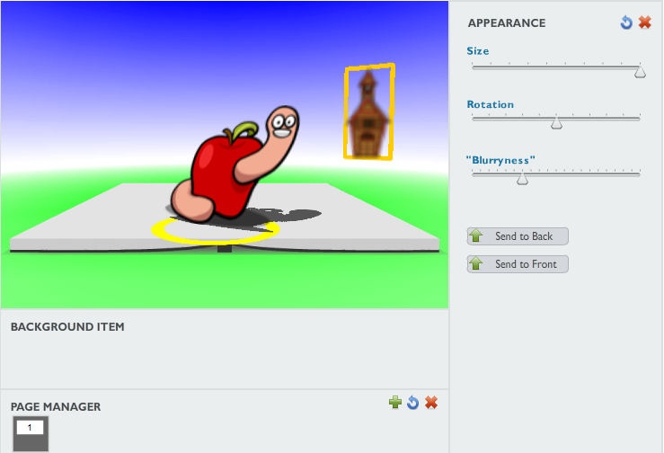
Once you have an item in your book you can drag and drop it anywhere on the current page. You can also use the 'Appearance' panel on the right side of the page to change the character's size, rotation, tilt and color. Keep in mind that your character must always be on the page - ZooBurst will display a red "No" symbol when your character hits a boundary.
You can also add characters and scenery elements to the background of your book. Simply click the 'Add Pictures to Background' button and then click on a character in the Pictures panel. The character will appear on the background (see schoolhouse) and you can drag it around and adjust its size and rotation using the Appearance panel.
If you want your characters to "speak" when clicked on, you can click on a character and then click on the 'Character Text' panel at the bottom of the screen to pull up a text editor. Anything you type in this editor will appear in a "chat bubble" over the character's head when you publish your book. This editor also allows you to make portions of your text bold faced, change the color of your text and even include links to other websites.

If you click on the book itself you will see the 'Book Appearance' panel appear on the right side of the screen. This panel lets you change the color of the sheet of paper as well as the color of the ground, horizon and sky.
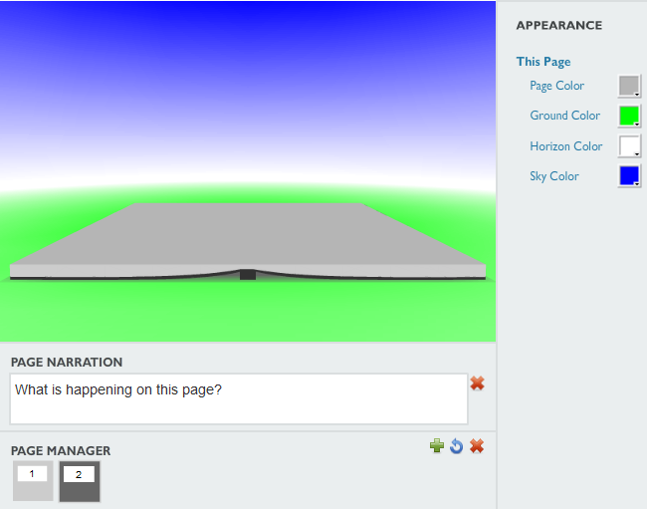
The page manager panel at the bottom of the screen lets you add in new pages, delete existing pages, duplicate pages and re-order pages. Keep in mind that Basic users can only have 10 pages per book.
When you are finished make sure to click the 'Save' button at the top right side of the screen to save your work. To view your book, select the 'Books' link at the top of the screen and then click on the 'View' button next to your newly-created book.

